 | Block 1 | Block 2 | Block 3 | Block 4 | Block 5
Transition Year  2 x 1 hour class per week | Contemporary Issues in Physical Education | Teaching Games For Understanding  (Lacrosse) | Sport Education | Personal & Social Responsibility | Adventure Education
5th Year  1 x 1 hour class per week | Sport Education  (5th Year Tag Rugby World Cup) | Teaching Games For Understanding  (Lacrosse) | Teaching Games For Understanding  (Volleyball) | Health Related Physical Activity | Personal & Social Responsibility
6th Year  1 x 1 hour class per week | Health Related Physical Activity | Teaching Games For Understanding  (Lacrosse) | Health Related Physical Activity  (Yoga) | Contemporary Issues in Physical Education | Teaching Games For Understanding

Aim and objectives:
Aim:
The aim of the senior cycle physical education framework is to encourage learners’ confident, enjoyable and informed participation in physical activity while in senior cycle and in their future lives.
Objectives:
The objectives of senior cycle physical education are to support learners in:
- Developing confidence, competence and creativity in a range of physical activities.
- Participating in physical activity both inside and beyond school.
- Examining the value of physical activity in different contexts.
- Understanding and committing to physical activity which develops health-related physical fitness.
- Undertaking different roles in physical activity.
- Demonstrating responsible social and personal behaviour in physical activity, including respect for self and others.
- Acting as informed participants in physical activity.

Senior Cycle Key Competencies:
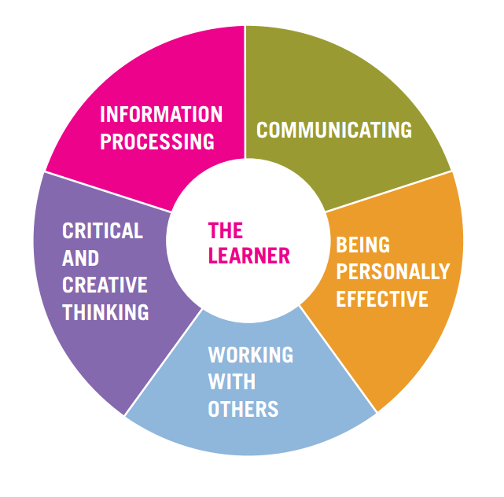

Health Related Physical Activity
Year Group and block: | Students learn about… | Students should be able to…
6th Year Block 1 | Health-related and performance-related physical fitness. | 1. Evaluate their own health-related physical fitness.  2. Compare the components of health-related and performance-related physical fitness.  3. Monitor their participation in activities designed to enhance one or more health-related fitness components using the FITT formula (Frequency, Intensity, Time and Type).
 | Physical activity participation. | 4. Discuss the benefits of regular physical activity that they have experienced as a result of their participation.  5. Identify different supports that helped them begin and/or continue to be physically active  6. Create a personal activity profile identifying abilities, attitudes, motivations and barriers to their own participation following a self- assessment.  7. Use a range of strategies to overcome barriers to regular participation in physical activity.  8. Identify physical activity opportunities in school and in their communities.
 | Designing a physical activity programme | 9. Identify reliable resources to support their planning of a health- related and/or performance-related physical fitness programme.  10. Use their personal physical fitness results to plan and implement an effective, enjoyable and balanced fitness programme which aims to improve health-related/ performance-related physical fitness.  11. plan a physical activity programme designed to enhance health- related physical fitness for an individual with an activity profile different to their own
 | Organising a physical activity event | 12. organise a health-related physical activity event  13. participate in and reflect on the health-related physical activity event
 | Evaluation of physical activity facilities, services and products | 14. evaluate a local health club/gym or physical activity facility or fitness service from a number of perspectives including that of a participant
 | Safety concerns pertaining to a variety of lifetime and fitness activities | 15. provide advice about appropriate clothing, hydration, safe practice and suitable equipment for health-related physical activities based on their experience  16. document the uses and misuse of supplements/drugs in physical activity and sport.
 | Wellbeing/Wellness | 17. include physical activity in their stress management plan  18.practice relaxation techniques  19. evaluate personal diet and nutrition habits  20. commit to a healthy, balanced eating plan which they have designed to meet the energy and nutritional demands of their physical activity levels

Sport Education
Year Group and block: | Students learn about… | Students should be able to…
5th Year Block 1 | Roles and responsibilities | 1. Undertake different playing and non-playing roles in the selected physical activity
5th Year Block 1 | Being an effective team member | 2. Participate as an effective member of a team working towards a common goal, for example, a culminating event, display, or performance  3. Demonstrate effective leadership in playing and non-playing roles
5th Year Block 1 | Effective personal performance | 4. Demonstrate the effective use of the skills, techniques and strategies of the activity  5. Observe the rituals and conventions of the activity  6. Adhere to the safety requirements of the activity  7. Develop the fitness requirements for the selected physical activity  8. Incorporate a variety of techniques, choreographic principles and approaches to group work in their dance/gymnastic performance  9. Demonstrate an understanding of aesthetic and artistic considerations in their performance  10. Work creatively with props in dance and small and large apparatus in gymnastics
5th Year Block 1 | Culminating physical activity event | 11. Organise a culminating event for the selected physical activity  12. Reflect on their own experience of organising and participating in a culminating event from an individual and/or group perspective
 | Physical activity opportunities beyond the physical education class | 12. Organise a health-related physical activity event  13. Participate in and reflect on the health-related physical activity event
 | Common sport injuries and their rehabilitation, first aid procedures including concussion and cardiopulmonary resuscitation (CPR). | 14. Show knowledge and understanding of common injuries in the chosen activity by including ways in which they can be avoided as they participate in the activity

Contemporary Issues in Physical Activity
Year Group and block: | Students learn about… | Students should be able to…
 | Different experiences of physical activity | 1. review two or more physical activity biographies of individuals, including their own  2. explain the role of family, friends, school and community in enhancing or inhibiting participation in physical activity
 | Physical activity opportunities in and beyond school | 3. critique opportunities for physical activity for students within and beyond the school  4. show evidence of participating in a physical activity other than physical education class  5. encourage others to participate in a physical activity of their choice  6. highlight physical activity opportunities including mass participation events in their locality
 | Barriers and supports in sport and physical activity | 7. evaluate the supports and barriers, both actual and perceived, to different groups’ participation in physical activity  8. identify occasions and/or practices where sport and physical activity are used to either support or oppress different groups of males and females  9. analyse the role of national and local policies in the promotion of physical activity and health  10. explain the role of the Local Sports Partnership including how it supports young peoples’ ongoing participation in physical activity  11. develop a resource which highlights the work of a National Governing Body of Sport and/or other groups whose aim it is to promote physical activity participation  12. critique facilities for physical activity in and beyond school from a number of perspectives, including safety, attractiveness, gender, age, and special needs  13. advocate with the relevant bodies for the improvement of physical activity facilities/opportunities in their local community
Transition Year Block 1 | Inclusive physical activity opportunities | 14. organise a physical activity event in their school/local community that is designed to be inclusive  15. design a promotional campaign to highlight opportunities for inclusive physical activity in their community
 | The influence of the media in physical activity and sport | 16. critically analyse the role of the media in relation to physical activity participation for both males and females and/or minority groups
Transition Year Block 1 | Sport and drug use | 17. document the uses and misuse of supplements/drugs in the sport  18. design a charter for safe participation in sporting activities

Adventure Education
Year Group and block: | Students learn about… | Students should be able to…
 | Challenging individual and group adventure activities | 1. participate in individual and group adventure activities which challenge them physically, mentally and/or emotionally
 | Setting goals | 2. set realistic personal goals for challenges which include opportunities for cooperation, appropriate risk-taking, building trust and/or problem-solving
 | Co-operation in adventure tasks | 3. contribute to problem-solving in group adventure activities  4. demonstrate an ability and willingness to adhere to an agreed protocol regarding their personal behaviour and their interactions with other group members
 | Reflection on learning experiences | 5. reflect on the different adventure challenges, including consideration of how their learning might be applied in future challenges
 | Creating adventure activity challenges | 6. develop their own adventure activity task(s) including organising them for another individual or group
 | Safety in adventure activities | 7. adhere to the necessary safety precautions in adventure activity challenges  8. demonstrate basic emergency first aid for outdoor adventure settings
 | Environmental features | 9. consider different environmental features when participating in adventure activities including landscape features, tide and weather variations
 | Undertaking an adventure activity expedition | 10. undertake a short expedition combining independent planning, navigation and adventure pursuit
 | Roles and responsibilities in Adventure education | 11. take responsibility for one or more roles in an adventure activity challenge  12. model the individual and team behaviours which contribute to team morale and effectiveness when participating in adventure activities
 | Benefits of adventure activity | 13. discuss the benefits of adventure activities for health and wellbeing

Personal and Social Responsibility
Year Group and block: | Students learn about… | Students should be able to…
 | Making and keeping agreements | 1. Negotiate the goals for physical education class  2. Express their opinions and suggestions clearly and respectfully  3. Resolve differences in a peaceful and respectful manner
 | Effort and participation | 4. Progress individual and group goals for effort and participation in the selected physical activities
 | Self-control | 5. Demonstrate the ability to take responsibility for their behaviour, commitment and progress in physical education class
 | Self-direction | 6. Set realistic and challenging goals for achievement in physical activity  7. Lead different classroom activities such as warm-ups, practices and small-sided games/performances  8. Reflect on their progress, including planning next steps
 | Respecting the rights and feelings of others | 9. Participate in physical activity in an inclusive way, being mindful of the needs and feelings of others
 | Leadership | 10. Demonstrate qualities of effective leadership as they undertake leadership roles in the organisation of, and participation in, physical activity  11. Demonstrate an ability to act responsibly when unsupervised
 | Applying what has been learnt to the wider context | 12. Plan to participate in physical activity outside of physical education class  13. Apply their learning about taking personal and social responsibility beyond physical education class

Teaching Games For Understanding
Year Group and block: | Students learn about… | Students should be able to…
 | Game appreciation | 1. outline the elements that give form to the selected game including rules, boundaries and scoring  2. critique if and how the rules contribute to making a game enjoyable and challenging  3. agree the ‘important rules’ that will be observed as they participate in the selected sport
 | Tactics and principles of play in  - striking and fielding games  - net/wall games  - invasion games  (Offensive and defensive play) | 4. set up an appropriate attacking play, either themselves or as a supporting player in different attacking scenarios  5. defend space on their play area when under attack in a variety of scenarios  6. participate effectively as part of a team, including communicating effectively
 | Games-making | 7. create a new game with their peers which demonstrates an understanding of the main tactics and principles of the games category being studied  8. Refine the game through a series of practices  9. teach the new game to their peers, including refining it as necessary

Assessment:
Students will create a portfolio outlining their learning experiences and this will be evaluated by their teacher using the features of quality below and will form part of their comment and assessment for reporting at Christmas, March and Summer.
Features of quality for students learning portfolio:
Achieved With Merit  All components of the portfolio are included in a well-organised fashion with a table of contents included. A variety of media is included. Items clearly represent evidence of learning for a selection of learning outcomes for this block of work. The learner displays a significant understanding of the  concepts and applications involved. There is substantial evidence of a capacity to reflect on how the learning is influencing their attitudes, opinions and behaviour. The self-evaluation component is completed showing clarity of thought and insight. | Achieved  Most components of the portfolio are included. Items represent learning in some of the selected learning outcomes for this block of work. The student has gained some understanding of the concepts and attempts to apply them. There is some evidence of a capacity to reflect on how the learning is  influencing their attitudes, opinions and behaviour. The self-evaluation component is completed and shows evidence of thought and careful consideration. | Incomplete  The portfolio is largely incomplete. There is little or no evidence of important learning. The student has very limited or no understanding of the concepts. There is little or no evidence of a capacity to reflect on learning. The self-evaluation component is not completed.

