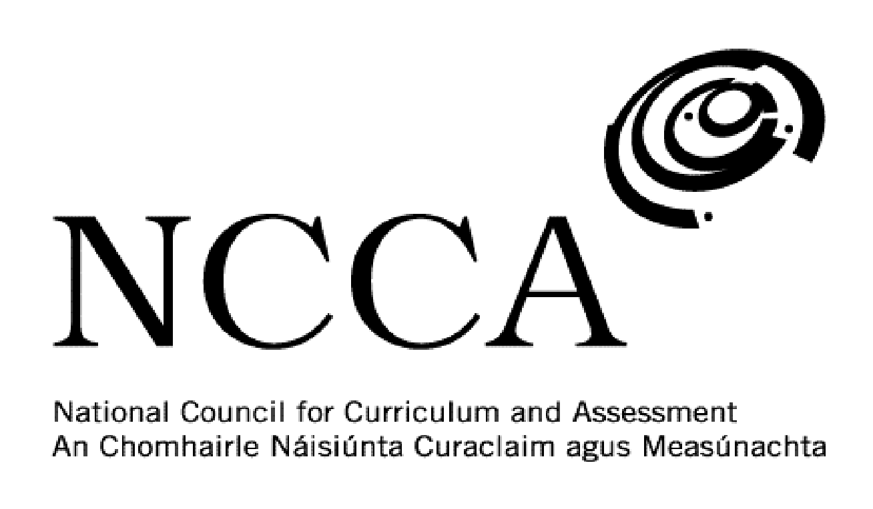

TRANSITION UNIT TEMPLATE

UNIT DESCRIPTOR

1. Title of transition unit
Culture.

2. Area of study
Modern world cultures - Ireland, Mexico and Germany.

3. Overview
This module is designed to look at culture. While students may have come across different aspects of culture particularly things like language, music, food and film, they may not have thought about the origins of them and how they are part of a wider culture. This module will give students an understanding of Irish culture while also examining the cultures of others students in their class who come from Mexico and Germany. Students will also watch films linked to Irish culture such as ‘My Left Foot’ and ‘The Commitments’.

Elements of culture to be examined include:

- Literature
- Fashion
- Dance
- Sport
- Art
- Language
- Religion/Traditions
- Film
- Food & Drink
- Music

4. Related learning
This module will cover a number of different areas such as English, modern languages, music, geography, history and religion.

5. Summary outline of the unit
Week 1 - Introduction - Discuss with students what they think culture is made up of. Use ‘cultural iceberg’ diagram as an aid.

Week 2 - Breakdown culture - Ireland as a case study. Students will come up with the various aspects that make up Irish culture and each will be assigned an area to research.

Week 3 - Work on cultural presentations and present to teacher. Using their iPads students will devise a presentation or video on an area of Irish culture that they then have to present to the class.

Week 4 - Watch ‘My Left Foot’ - Students will watch this film on the life of writer and painter Christy Brown. They will complete a worksheet at the end.

Week 5 - Watch ‘The Commitments’ - Students will watch this film about Dublin in the late 1980s and what aspects of culture from another country are shown in the film. They will complete a worksheet at the end.

Week 6 - Watch an episode of ‘Father Ted’ to show students how comedy was used to hold a mirror up to Irish society and how the shows popularity was evidence of the declining influence of the Catholic Church on Irish society.

Week 7 - Look at the culture of a student from another country - Mexico. Break down the culture into its key components as done for Ireland.

Week 8 - Look at the culture of students from another country - Germany. Break down the culture into its key components as done for Ireland. Students complete their module evaluation sheets in this week.

6. Breakdown of the unit (How timetabled)
3 classes per week. Each class is 40 mins long. 8 weeks long.

7. Aims (maximum 3)
This transition unit aims to:
- Deepen students knowledge of Irish culture.
- Explore the cultures of foreign students in the class.
- Develop students use of iPads and IT.

8. Learning outcomes
On completion of this unit students should be able to:
- Explain the different components that make up culture.
- Examine Edward Hall’s ‘cultural iceberg’.
- Present a PowerPoint presentation or video on some aspect of Irish culture.
- Demonstrate good communication skills.
- Describe the culture of another country.
- Present a PowerPoint presentation or video on some aspect of another country’s culture.
- Analyse the film ‘The Commitments’ and the aspects of Irish culture it shows.
- Analyse the film ‘My Left Foot’ and the aspects of Irish culture it shows.

9. Key skills | How evidenced
information processing | Researching and recording information on Irish culture and the cultures of Mexico and Germany.
critical and creative thinking | Being able to look at culture from multiple points of view. Using iPads as part of a creative assessment plan. Understanding the value of looking at different cultures and making comparisons and contrasts.
communicating | Presenting a PowerPoint Presentation or video to the class on an aspect of Irish culture and the culture of another country.
working with others | Listening to one another’s presentations and/or videos. Collaborating with one another when the different aspects of culture have been issued to each student for investigation.
being personally effective | Students take responsibility for their own learning by being in class on time, having the necessary materials and managing their time to allow for assessment work to be handed in to the teacher on time.
10. Teaching approaches
Group work, pair work, open ended questions, class discussions, utilising ICT, investigation work, class presentations/videos.

11. Assessment approaches
PowerPoint presentation or video presentation using iMovie maker.

Worksheets on films watched.

12. Evaluation
As part of the self-assessment students will complete an evaluation sheet and discuss this with the teacher.

13. Resources
Whiteboard and markers, iPad and apps, PowerPoint presentations, websites, DVD, YouTube, photos.

