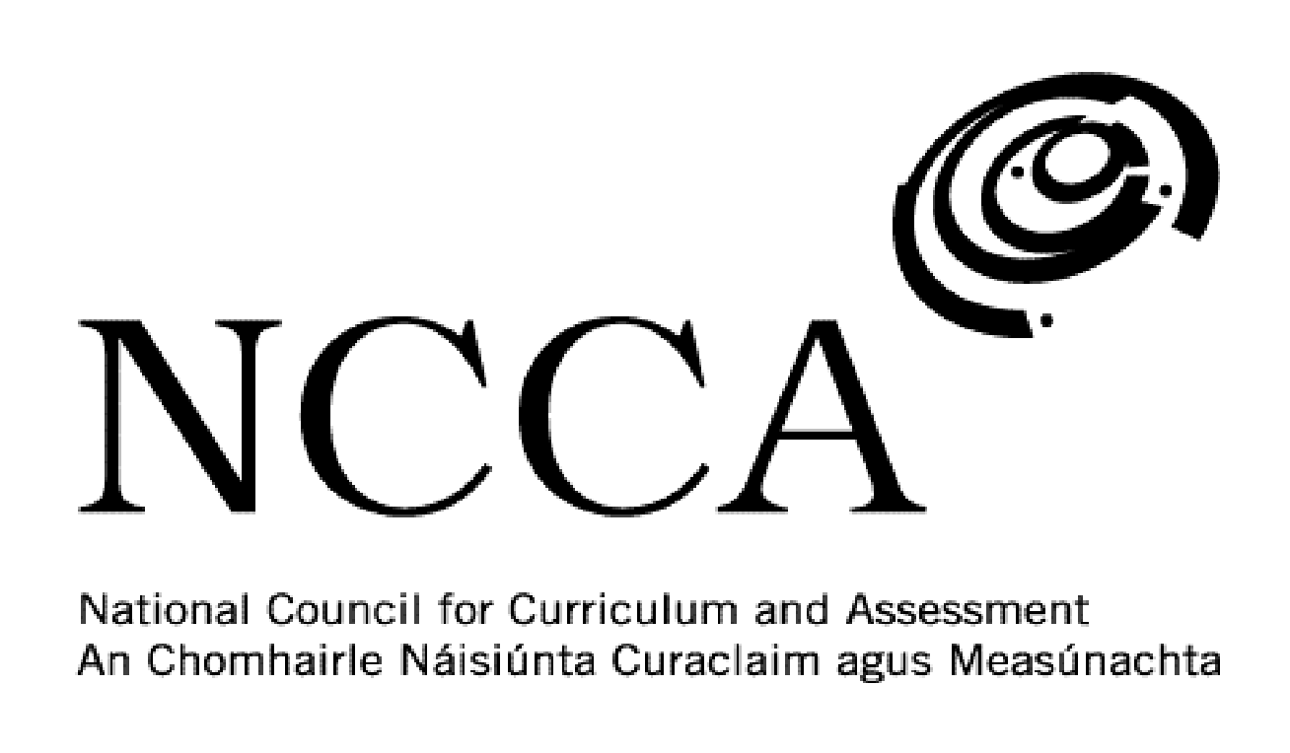

TRANSITION UNIT TEMPLATE

UNIT DESCRIPTOR

1. Title of transition unit
Culture.

2. Area of study
Modern world cultures – Ireland & Spain.

3. Overview
This module is designed to look at culture. While students may have come across different aspects of culture particularly things like language, music, food and film, they may not have thought about the origins of them and how they are part of a wider culture. This module will give students an understanding of Irish culture while also examining the cultures of others students in their class who come from Spain.

Elements of culture to be examined include:

- Literature
- Fashion
- Dance
- Sport
- Art
- Language
- Religion/Traditions
- Film
- Food & Drink
- Music

4. Related learning
This module will cover a number of different areas such as English, modern languages, music, geography, history and religion.

5. Summary outline of the unit
Week 1 - Introduction - Discuss with students what they think culture is made up of. Use ‘cultural iceberg’ diagram as an aid.

Week 2 - Breakdown culture - Ireland as a case study. Students will come up with the various aspects that make up Irish culture and each will be assigned an area to research.

Week 3 - Work on cultural presentations and present to teacher. Using their iPads students will devise a presentation or video on an area of Irish culture that they then have to present to the class.

Week 4 – Students present to the class their presentations on Irish culture.

Week 5 - Look at the culture of a student from another country - Spain. Break down the culture into its key components as done for Ireland.

Week 6 - Work on cultural presentations and present to teacher. Using their iPads students will devise a presentation or video on an area of Irish culture that they then have to present to the class.

Week 7 – Students present to the class their presentations on Spanish culture.

Week 8 – Cultural film.

6. Breakdown of the unit (How timetabled)
3 classes per week. Each class is 40 mins long. 8 weeks long.

7. Aims (maximum 3)
This transition unit aims to:
- Deepen students’ knowledge of Irish culture.
- Explore the culture of Spanish students in the class.
- Develop students’ use of iPads and IT.

8. Learning outcomes
On completion of this unit students should be able to:
- Explain the different components that make up culture.
- Examine Edward Hall’s ‘cultural iceberg’.
- Present a PowerPoint presentation or video on some aspect of Irish culture.
- Demonstrate good communication skills.
- Describe the culture of another country.
- Present a PowerPoint presentation or video on some aspect of another country’s culture.
- Watch a film in the final week which has a particularly strong cultural theme.
9. Key skills | How evidenced
information processing | Researching and recording information on Irish culture and the culture of Spain.
critical and creative thinking | Being able to look at culture from multiple points of view. Using iPads as part of a creative assessment plan. Understanding the value of looking at different cultures and making comparisons and contrasts.
communicating | Presenting a PowerPoint Presentation or video to the class on an aspect of Irish culture and the culture of another country.
working with others | Listening to one another’s presentations and/or videos. Collaborating with one another when the different aspects of culture have been issued to each student for investigation.
being personally effective | Students take responsibility for their own learning by being in class on time, having the necessary materials and managing their time to allow for assessment work to be handed in to the teacher on time.
10. Teaching approaches
Group work, pair work, open ended questions, class discussions, utilising ICT, investigation work, class presentations/videos.

11. Assessment approaches
PowerPoint presentation or video presentation using iMovie maker.

Worksheet on film watched.

12. Evaluation
As part of their self-assessment students offer their opinion of what went right during the project, what went wrong and what they would differently if they did the project again.

13. Resources
Whiteboard and markers, iPad and apps, PowerPoint presentations, websites, DVD, YouTube, photos.

