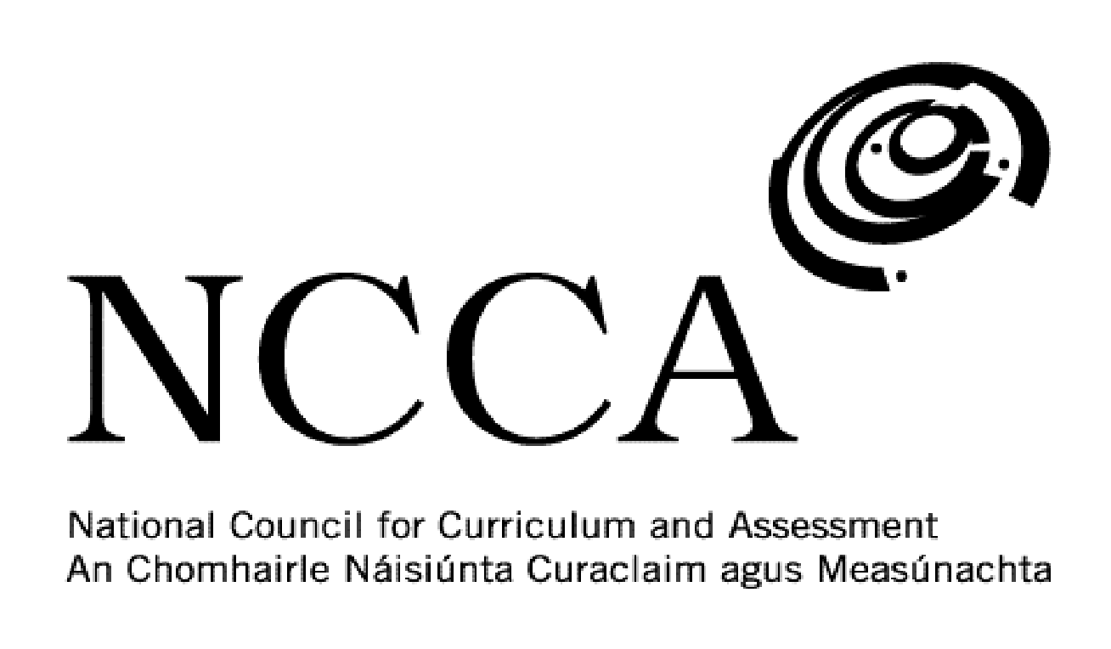

TRANSITION UNIT TEMPLATE

UNIT DESCRIPTOR

1. Title of transition unit
Family tree

2. Area of study
Genealogy

3. Overview
This module is intended to get Transition Year students to research their own family tree. A core part of the module will be developing the students’ research skills. The students will record the information they gather on poster sheets. Both the maternal and paternal lines will be studied going as far back as great grandparents. Students will have to discover information relating to each person in the following areas:

Name
Birth & death dates
Where they lived
Education
Occupation
Any other information

4. Related learning
This module will primarily focus on history but will have links to Geography and English.

5. Summary outline of the unit
Week 1 – Introduction – Introduce the idea of a family tree to the students. Show them examples of last years’ family tree poster that hang in the History room. State clearly what information is expected on each person.

Week 2 – Poster design – Students are given A3 sheets and begin to design a family tree. Students do not have to follow a strict design and can be creative in this regard.

Week 3 – Information – Students begin to fill in information on their poster sheets. Phone calls to grandparents in particular if possible will be very helpful in the research process.

Week 4 – Presentation – Students put the finishing touches on their posters and then present to the class their main discoveries. This will engage students in the art of public speaking.

6. Breakdown of the unit (How timetabled)
3 classes per week. Each class is 40 mins long. 4 weeks long.

7. Aims (maximum 3)
This transition unit aims to:
- Develop students’ research skills.
- Discover information about their family and their place in History.
- Enhance students use of IT and iPad apps.

8. Learning outcomes
On completion of this unit students should be able to:
- Show evidence of research on their family tree.
- Produce a family tree on A3 poster sheets
- Present to the class publicly what they discovered.
- Gain an appreciation for genealogy as an area of study.

9. Key skills | How evidenced
information processing | Researching and recording source information on a weekly basis. Taking down and recording key information each week.
critical and creative thinking | Being able to create a poster and decorate it accordingly.
communicating | Presenting a talk on what they discovered about their own family.
working with others | Listening to one another’s presentations and sharing ideas during the weeks when the posters are being made.
being personally effective | Students take responsibility for their own learning by being in class on time, having the necessary materials and managing their time to allow for assessment work to be handed in to the teacher on time.
10. Teaching approaches
Group work, pair work, open ended questions, utilising ICT, investigation work, problem solving and decision making, class presentations/videos.

11. Assessment approaches
Family tree poster presented to the class.

12. Evaluation
Students evaluate their poster and where they might improve if doing this project again.

13. Resources
Whiteboard and markers, iPad and apps, PowerPoint presentations, websites, DVDs, YouTube, newspapers, photos, articles.

