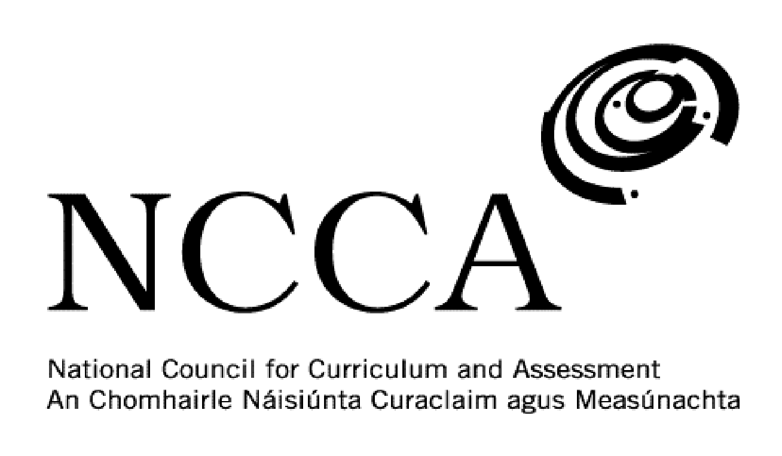

TRANSITION UNIT TEMPLATE

UNIT DESCRIPTOR

1. Title of transition unit
African-American history.

2. Area of study
Modern US History.

3. Overview
This module is intended to get Transition Year students to analyse and examine African-American history. This area of History receives very little attention if any at all in the Junior Cert History course. It is also an optional topic for the Leaving Cert History course. Fortunately at Loreto Abbey Dalkey it is a subject students would take if they choose to do History. It is a topic that many students find fascinating but don’t know a lot about. African-American history has had a major impact on history, culture, arts and music. This module will help students understand the complex history of African-Americans.

This module will look at six main areas of African-American history, which is hoped will give students a better understanding and knowledge of this period in history. The six areas for study are:

- Slavery,
- Jim Crow laws,
- Racial violence - Lynchings - Emmet Till
- Civil rights movement - Rosa Parks, Martin Luther King Jr., Birmingham church bombing
- Songs such as ‘Strange Fruit’, ‘We Shall Overcome’, ‘The Hurricane’
- Watch ‘Selma’

4. Related learning
This module will primarily focus on history but will have links to English, Music and Film Studies.

5. Summary outline of the unit
Week 1 - Slavery - Students will look at the history of slavery in the United States. Why were Africans brought to America? What was life like on a southern plantation? What steps were taken to abolish slavery?

Week 2 - Jim Crow Laws/Segregation - How and why was inequality allowed to exist? Students will examine the notion of ‘separate but equal’ and look at real examples of this policy.

Week 3 - Racial violence - Students will look at the setting up of the Ku Klux Klan as a racist organisation against African-Americans. They will also look at the history of lynchings and famous murders such as that of 14 year old Emmet Till.

Week 4 - The Civil Rights Movement - Why did this movement emerge? Who were it’s leaders and what were their demands? Students will analyse key events and personalities in the Civil Rights struggle such as ROsa Parks and the Montgomery Bus Boycott and Martin Luther King Jr. and his famous ‘I Have A Dream’ speech.

Week 5 - Songs - Students will analyse the meaning behind songs such as ‘Strange Fruit’, ‘We Shall Overcome’ and ‘The Hurricane’. It will give students an insight into how music helped to convey a message to a wider audience.

Week 6 - ‘Selma’ - Students will watch the Oscar-winning film ‘Selma’. They will complete a worksheet on the film.

Week 7 - Finish off watching ‘Selma’. Students will complete their film worksheet and submit their project work to the teacher. They will fill out an evaluation sheet and hand it to the teacher.

6. Breakdown of the unit (How timetabled)
3 classes per week. Each class is 40 mins long. 7 weeks long.

7. Aims (maximum 3)
This transition unit aims to:
- Develop students understanding of African-American history.
- Analyse how songs can be used to convey a political or social message.
- Enhance students use of IT and iPad apps.

8. Learning outcomes
On completion of this unit students should be able to:
- Explain how slavery became important to the southern US economy.
- Detail the development of the abolition movement.
- Analyse the many segregation laws that were enforced in the southern US but also discrimination faced in northern states.
- Describe why the Ku Klux Klan was set and some famous examples of racial violence.
- Evaluate the importance of protest songs in the movement for better rights.
- Name the main leaders of the Civil Rights movement.
- Complete a worksheet on the film ‘Selma’.

9. Key skills | How evidenced
information processing | Researching and recording source information on a weekly basis. Taking down and recording key information each week.
critical and creative thinking | Being able to look at African-American history from multiple sources and analysing them. Using iPads as part of a creative assessment plan.
communicating | Presenting a PowerPoint Presentation or video to the class on a topic from the module.
working with others | Listening to one another’s presentations and/or videos. Organising and delegating work within a group, taking responsibility for sharing the work and completing to an agreed time frame.
being personally effective | Students take responsibility for their own learning by being in class on time, having the necessary materials and managing their time to allow for assessment work to be handed in to the teacher on time.
10. Teaching approaches
Group work, pair work, open ended questions, utilising ICT, investigation work, problem solving and decision making, class presentations/videos.

11. Assessment approaches
PowerPoint presentation or video presentation using iMovie maker.

Complete worksheet.

12. Evaluation
As part of the self-assessment students will complete an evaluation sheet and discuss this with the teacher.

13. Resources
Whiteboard and markers, iPad and apps, PowerPoint presentations, websites, DVDs, YouTube, newspapers, photos, articles.

