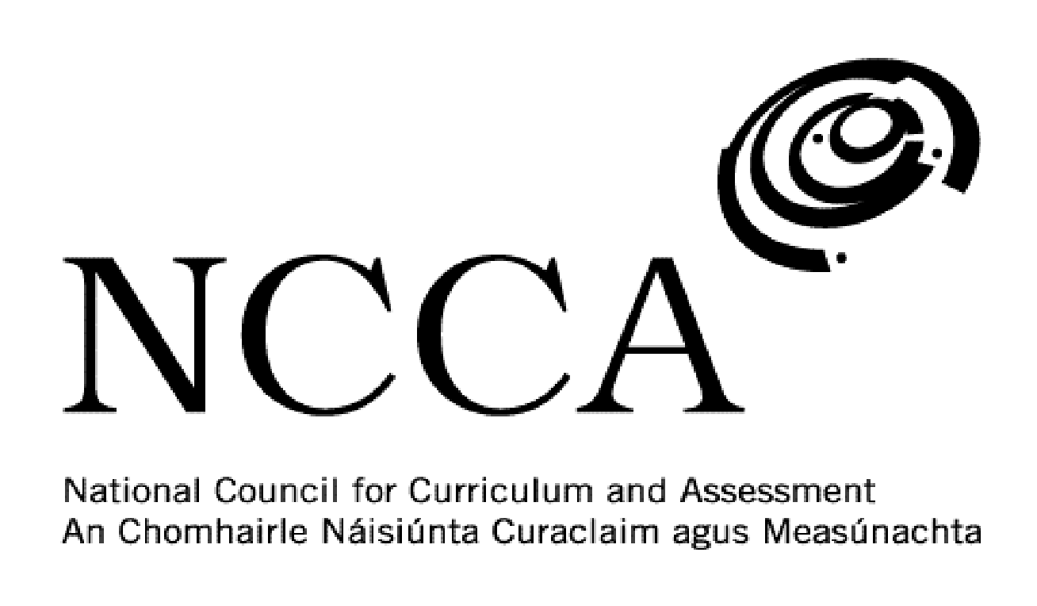

TRANSITION UNIT TEMPLATE

UNIT DESCRIPTOR

1. Title of transition unit
The Holocaust.

2. Area of study
Modern European history.

3. Overview
This module is intended to get Transition Year students to analyse and examine the Holocaust. The Holocaust was a major event in modern European history and a famous example of genocide. Students will have background knowledge from the 3rd Year History course and some students may have visited sites linked to it. This module will allow students to go into greater detail on this event and study it from multiple sources. The module will look at the history of anti-semitism, through to Hitler and Nazis in power, finally to the death camps and the end of the Holocaust.

This module will look at seven main areas on the Holocaust, which is hoped will give students a better understanding and knowledge of this period in history. The seven areas for study are:

- Anti-semitism in Europe
- The rise of the Nazis
- The persecution of German Jews
- World War 2
- The Wannsee Conference
- Concentration and Death camps
- Watch ‘Schindler’s List’

4. Related learning
This module will primarily focus on history but will have links to Geography, English, Religion and Film Studies.

5. Summary outline of the unit
Week 1 - Anti-Semitism in Europe - Students will examine the history of anti-semitism in Europe and how it manifested itself in laws, attacks and pogroms. Make comparisons to anti-semitism in other countries such as Russia and the 1904 Limerick Boycott in Ireland.

Week 2 - The rise of the Nazis - Study what the prime motivations of the Nazi Party were and what led to its increased support between 1929 and 1933. Look at the lives of key Nazi Party leaders such as Adolf Hitler, Hermann Goering, Joseph Goebbels and Heinrich Himmler.

Week 3 - The persecution of German Jews in the 1930s - Students will analyse the anti-semitic laws introduced in Germany, particularly the 1935 Nuremberg Laws. Why were they introduced and what effect did they have on Jewish life? Did they lead to Jews leaving Germany?

Week 4 - World War 2 & The Wannsee Conference - Students will analyse the key events in the Holocaust during World War 2, including the 1942 Wannsee Conference which decided the methods of killings to be employed in concentration and death camps.

Week 5 - Concentration and Death Camps - What was the purpose of these camps? Discuss what types of prisoners were first sent to concentration camps. Examine which were the most infamous camps and how people were killed there - Auschwitz, Treblinka, etc.

Week 6 - Schindler’s List - Watch film DVD with students and get them to complete a worksheet of questions.

Week 7 - Schindler’s List - Finish off film and worksheets. Have a class discussion on the film and the main Holocaust themes conveyed. Use mentimeter to visualise the main words that students think of.

Week 8 - Evaluation and final assessment. Students will complete an essay on an aspect of the Holocaust that they choose. They will also complete a self-assessment and reflection form. This will then be discussed with the teacher and the rest of the class.

6. Breakdown of the unit (How timetabled)
3 classes per week. Each class is 40 mins long. 8 weeks long.

7. Aims (maximum 3)
This transition unit aims to:
- Deepen students understanding and knowledge of the Holocaust.
- Get students to view the event from the viewpoint of the perpetrators and the victims.
- Encourage students to analyse and examine various source material on the Holocaust

8. Learning outcomes
On completion of this unit students should be able to:
- Explain what anti-semitism was and why it occurred in Europe
- Judge the motivations of Nazi leaders and why many German people supported them
- Describe what life was like for Jews living in 1930s Germany.
- Gain an understanding as to why the Wannsee Conference took place
- Discuss the operations of Nazi concentration and death camps
- State the main themes conveyed in ‘Schindler’s List’
- Consider the importance of films like ‘Schindler’s List’ in Holocaust remembrance
- Enhance their essay writing skills
- Source information for their essay

9. Key skills | How evidenced
information processing | Researching and recording source information on a weekly basis. Taking down and recording key information each week.
critical and creative thinking | Being able to look at an event from multiple sources and analysing them. Using iPads as part of a creative assessment plan. Understanding the value of source analysis. Analytically studying sources on a weekly basis.
communicating | Presenting a PowerPoint Presentation or video to the class on a topic from the module.
working with others | Listening to one another’s presentations and/or videos. Organising and delegating work within a group. Taking responsibility for sharing the work and completing to an agreed time frame.
being personally effective | Students take responsibility for their own learning by being in class on time, having the necessary materials and managing their time to allow for assessment work to be handed in to the teacher on time. Students will also be able to demonstrate personal responsibility by providing sources for their written essay.
10. Teaching approaches
Group work, pair work, open ended questions, utilising ICT, investigation work, problem solving and decision making, class presentations/videos

11. Assessment approaches
Presentation or video.

Worksheet.

Written essay.

12. Evaluation
As part of the self-assessment students will complete an evaluation sheet and discuss this with the teacher.

13. Resources
Whiteboard and markers, iPad and apps, PowerPoint presentations, websites, DVDs, YouTube, newspapers, photos, video clips and articles.

