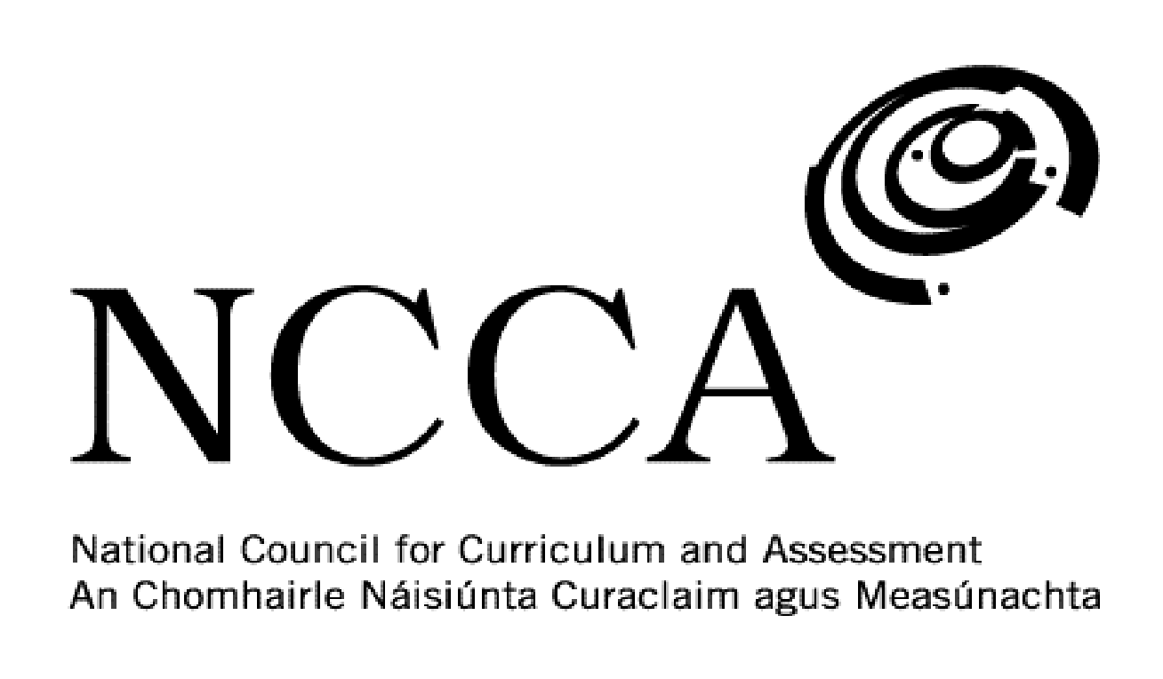
TRANSITION UNIT TEMPLATE

UNIT DESCRIPTOR

1. Title of transition unit
World War 1.

2. Area of study
Modern European and Irish history.

3. Overview
This module is intended to get Transition Year students to look in greater details at different aspects of World War 1. The war itself had a major impact on 20th century European and Irish history. Students will have some brief knowledge of the war from the Junior Cert History course. However, the course does not go into the war in any major and meaningful way. All that is essentially required is to know the main participating countries, Franz Ferdinand’s assassination and the main stipulations of the Treaty of Versailles, 1919.

This module will look at four main areas on the war, which is hoped will give students a better understanding and knowledge of this period in history. The four areas for study are:

- The causes of World War 1
- Life in the trenches
- Irish involvement in the war
- The role of women in the war

4. Related learning
This module will primarily focus on history but will have links to Geography, English and Film Studies.

5. Summary outline of the unit
Week 1 - Introduction & the causes of World War 1. Discuss with the students how the module will develop and be assessed. Ask students questions to gauge their knowledge of World War 1. Use mentimeter to see what words and themes emerge most. Analyse and examine with students the major causes of the war such as imperialism and colonial rivalry, tensions in the Balkans, nationalism and the Anglo-German naval race.

Week 2 - The assassination of Franz Ferdinand. Look at those responsible and their motives. Watch history DVD (‘Days That Shook The World’) of the event to gain a greater understanding.

Week 3 - Life in the trenches. Examine and detail how the trench system developed. Discover what routine life was like in the trenches for the average soldier. What hardships did they endure - rats, disease, shooting, shelling, ‘shell shock’, trench foot, etc.

Week 4 - Watch film ‘The Trench’ - discuss with students what areas of trench life they have studied that they saw in the film.

Week 5 - Irish involvement in the war - Students will study the main reasons Irishmen joined the British Army - nationalism, unionism, economic reasons, family tradition, adventure, peer pressure. Research the lives of Irishmen who fought in the war such as Tom Kettle, Willie Redmond, William McFadzean, Francis Ledwidge and Fr. Willie Doyle. Use comic books from the National Library of Ireland designed by ‘Creative Centenaries’.

Week 6 - Women in the war - examine the role women played in the munitions factories and the effect this may have had on women demanding greater rights - women’s suffrage. Study the work carried out by nurses at the front. Watch Kate Adie’s “Women of World War One” BBC programme on DVD.

Week 7 - Watch ‘Coward’ mini-film and have a class discussion on the message being conveyed. Classroom assessment using Kahoot. Students must also submit their PowerPoint presentation, iMovie video or iBook comic to the teacher. Students will complete a self-assessment and reflection form. This will then be discussed with the teacher and the rest of the class.

6. Breakdown of the unit (How timetabled)
3 classes per week. Each class is 40 mins long. 7 weeks long.

7. Aims (maximum 3)
This transition unit aims to:
- Deepen students knowledge of World War 1.
- Examine Ireland’s involvement in the war.
- To analyse how the war impacted on women.

8. Learning outcomes
On completion of this unit students should be able to:
- Explain the main causes of World War 1 and how they were interconnected.
- Judge if the assassination of Franz Ferdinand made war unavoidable.
- Describe what life in the trenches was like for the ordinary soldiers who experienced it.
- Gain an appreciation of how the war created a generation of ‘soldier-poets’.
- Discuss the various reasons why Irishmen joined the British Army to fight in the war.
- State how many Irishmen fought in the war and how many died.
- Assess how the war changed the nature of the work women did.
- Consider the difficulties faced by nurses on the frontline.
- Enhance their IT skills by use of the iPads

9. Key skills | How evidenced
information processing | Researching and recording source information on a weekly basis. Taking down and recording key information each week.
critical and creative thinking | Being able to look at an event from multiple sources and analysing them. Using iPads as part of a creative assessment plan. Understanding the value of looking at World War 1 from various sources. Analytically studying sources on a weekly basis.
communicating | Presenting a PowerPoint Presentation or video to the class on a topic from the module.
working with others | Listening to one another’s presentations and/or videos. Collaborating with one another on their comic or book when using iBook creator. Organising and delegating work within a group, taking responsibility for sharing the work and completing to an agreed time frame.
being personally effective | Students take responsibility for their own learning by being in class on time, having the necessary materials and managing their time to allow for assessment work to be handed in to the teacher on time.
10. Teaching approaches
Group work, pair work, open ended questions, utilising ICT, investigation work, problem solving and decision making, class presentations/videos.

11. Assessment approaches
PowerPoint presentation or video presentation using iMovie maker.

Design a comic using iBook creator.

Kahoot class test.

12. Evaluation
As part of the self-assessment students will complete an evaluation sheet and discuss this with the teacher.

13. Resources
Whiteboard and markers, iPad and apps, PowerPoint presentations, websites, DVDs, YouTube, newspaper clippings, photos, comics, articles.

